Dear Parishioners of St Marys with St Bernard’s.
The situation with the Corona Virus continues to affect the whole world and our own community. I ask you and your families as the Domestic Church at home, in these times, to pray !
Prayer for the Christian, has always been the first line of defence throughout the centuries in these types of afflictions. Therefore, I invite you to pray the Rosary at 9pm each evening in your own homes, and so continue to unite our parish in prayer over these weeks ahead. We pray for deliverance and protection, for the souls of those who have died, those being treated in hospitals, and especially for all the many medical staff throughout the world.
You may also wish to pray this Novena to Our Lady of Monte Berico.
See also an Act of Spiritual Communion for us unable to come to Holy Mass at present.
God Bless
Fr. Travers
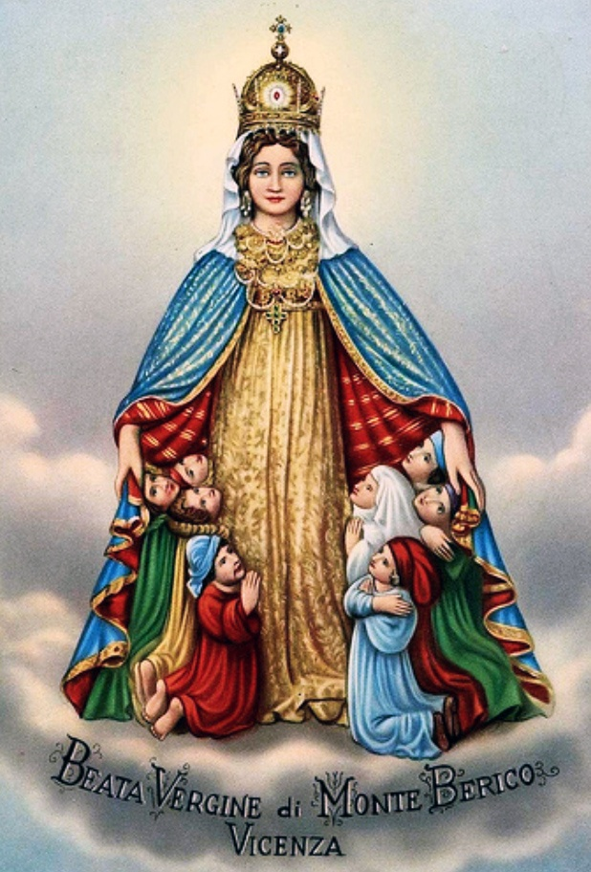
Most of the world may have never heard of St. Vincenza Pasini, but she was a prayerful peasant’s wife who understood the important of the earliest appeals for prayer. The people of the historical city of Vicenza, Italy in the early 15th-century were somewhat dissimilar to Pasini. Desperate in their own way, they had been fighting a pestilence for over a decade, when in 1426, Vincenza told the townspeople that as she was bringing lunch and drink to her husband labouring on a nearby hill overlooking the valley, the Virgin Mary appeared to her with instructions.
The Blessed Virgin promised that the people of Vicenza would be delivered from the plague if on the spot of the apparition, they built a church. “I am the Virgin Mary, the Mother of Christ who died on the cross for the salvation of men. I beg you to go and say in my name to the people of Vicenza that they must build in this place a church in my honour if they want to recover their health. Otherwise, the plague will not cease.”
Even Pasini was somewhat unconvinced, replying to Mary of the despondent and spiritual visionlessness of the local peoples. Our Lady assured her, “As proof of what I say, let them dig here, and from the rock, living water will spring.” Immediately obedient, the 70-year-old woman preached this message on the streets, but the message fell on deaf ears, and the plague raged on without hope of a respite or an end in sight. But Pasini continued to devote herself to Christian charity and the message of the woman who appeared to her, visiting the spot of the apparition daily, where the Virgin herself struck the ground in the shape of a cross and the dimension of the church to be build alongside the vineyard her husband worked from.
After two years, the Virgin appeared to her once again with the same message. With renewed vigor she told the people including the bishop, who opted, finally, after some 70% of the population had left or deceased, to build the church on a spot in the most northern expanse of the Colli Berici hills. At once, upon the completion and consecration of the church, the plague that had ravaged the entire region for years ended without any doubt left in the hearts and minds of the people of the city and local area. But the Virgin didn’t desire only a memorial to a moment of desperation, but a continued devotion. She vowed, “You will also say that those who visit this church on feasts dedicated to me and on the first Sunday of every month will have abundant graces and my will receive my maternal blessing.”
To this day, the people of Vicenza and the entire surrounding valley pour upon the hill on Marian feast days and the first Sundays of each month. I used to live on this hill, about a five-minute walk from the basilica, and I can assure you that nearly 600 years later on these days it is nearly impossible to get around the traffic and the massive crowds heading to standing-room-only Masses. Whether it amounts to local tradition or a pious devotion, the apparition is still highly regarded in the Veneto region. The image of the Virgin of Monte Berico (see above) is iconic, too. She dons a stunning crown and marvellous jewel-studded neckpiece. What’s more is the novel depiction of her as the mother-protector: she stands with her mantle open, sheltering the people under her intercessory protection.
Historically associated with plagues, the Madonna of Monte Berico is the perfect intercessor for our current coronavirus outbreak. The following novena may be said and offered for the petition of a swift end to the spread and for a maternal protection for all.
Novena to Our Lady of Monte Berico
O Most Holy Virgin, Mother of God and my Mother Mary, I thank you that you have deigned to appear on Monte Berico and I thank you for all the graces you grant here to those who turn to you. Nobody ever prayed to you in vain. I, too, resort to you and beg you for the Passion and Death of Jesus and for your pains: welcome me, o’ merciful Mother, under your mantle, which is a maternal mantle; grant me the particular grace that I ask of You [your petition here] and protect me from all evil and especially from sin which is the greatest evil. Oh make, oh Mary, my Mother, that I always enjoy your loving protection in life and even more in death and then come to see you in heaven and to thank and bless you forever. Amen.
Madonna of Monte Berico, pray for us.
O sweet Virgin, pious mother of love,
Like this Ave rising from the heart.
Ave, ave, ave, Maria
Ave, ave, ave, Maria
O Virgin, shine as a star in the sky,
Motherly defend your faithful children.
Ave, ave, ave Maria
Ave, ave, ave, Maria
Act of Spiritual Communion
The Church encourages frequent, even daily, Holy Communion, but if at any time we cannot go to Mass in or out of this season of the coronavirus, we can still unite ourselves to the Eucharist through making a spiritual Communion.
By making an Act of Spiritual Communion, we express our faith in Christ’s Real Presence in the Eucharist and ask him to unite himself with us. Here is the Act of Spiritual Communion written by St. Alphonsus de Liguori:
My Jesus,
I believe that You
are present in the Most Holy Sacrament.
I love You above all things,
and I desire to receive You into my soul.
Since I cannot at this moment
receive You sacramentally,
come at least spiritually into my heart.
I embrace You as if You were already there and unite myself wholly to You. Never permit me to be separated from You.
Amen.

